**18. Intelligent Operations**

Shivakumar R Goniwada[**1**](https://learning.oreilly.com/library/view/cloud-native-architecture/9781484272268/html/511610_1_En_18_Chapter.xhtml#Aff2)

(1)

Bangalore, India

In modern-day technology, with our increasingly disruptive and complex world, changes come quickly, often without warning. Customer expectations are exceeding the abilities of traditional management. Such trends turn today’s best practices into tomorrow’s liabilities. Enterprises that are following the traditional approach for managing systems simply can’t deliver what is needed to maintain next-generation customers. To survive and thrive today and in the future, enterprises must be able to act quickly with intelligence.

The implications of this new mandate particularly affect business operations, the heart of the entire industry. Enterprises are required to make fundamental changes and transform operations to be the intelligence engine. Most researchers believe the future belongs to intelligent operations, enabling quicker, insight-led decision-making.

Enterprises are required to embrace artificial intelligence for IT operations (AIOps) for tools, processes, and best practices for streamlining the complexities of IT. AIOps works with DevOps teams to quickly identify and fix issues that affect the behavior of an enterprise system.

In all these chapters, you have learned about the architecture, design, and development of a cloud native application. In this chapter, I will cover what you need to do post-production deployment. Operation management is a huge subject area, but I am restricting myself to concentrating on intelligent operations because that is the future. One thing you need to keep in mind is that you need to architect and design your systems for the best operations.

In this chapter, I will explain the following:

* AIOps
* Essentials of intelligent operations
* How data is important for the operation
* How you can leverage the power of the cloud
* ChatOps

**Introduction**

As cloud native accelerates, organizations are becoming increasingly dependent on IT. Service downtime and outages have an enormous business impact that leads to unhappy customers. How IT operates is one of the major elements of cloud native transformation, tasked with meeting demanding scalability, availability, and performance SLAs. At the same time, IT operations are expected to be an equal partner in innovation and agility, but sometimes organizations neglect the operations part. This is the sad part of IT.

With unicorns and modernized competitors emerging, the challenges are immense. Customer expectations are to have better quality with high performance. Whatever the approach your organization is adopting to improve performance, process optimization, cost reduction, and predictability may not be able to meet the present-day expectations. To survive the competition, you must adopt agility, intelligence, flexibility, and responsiveness.

There has been various research conducted by leading research institutes. The outcome of this research is that the “future belongs to an organization with intelligent operations,” and that enables you to have a 360-degree view of the operation, enabling quicker, insight-led decision-making.

A study supported by Accenture and Hfs Research highlights that digital disruption. An explosion of data and the customer experience are the driving forces behind the need for enterprises to transform how they do business and move toward intelligent operations.

* Nearly 80 percent of enterprises are concerned with disruption and competitive threats, especially from the unicorns.
* Data is rapidly shifting from a peripheral component to a fundamental driver of operations and competitive advantage.
* A robust customer experience strategy is the most significant driver of operational agility.

With intelligent operations at the center of the enterprise, your organization can become more flexible, responsive, and more agile; can generate value more quickly; and can achieve a sustainable competitive advantage.

The intelligent operation is embedding advanced intelligence and automation capabilities into the core operational process. It enhances decision-making across operations based on operational data.

Intelligent operation is a new strategy for companies seeking to achieve operational excellence (OE) aligned with the OE 4.0 approach. This move shifts the focus from a reactive to a predictive approach while improving operational performance. This requires accurate and single-source data, so companies can embrace intelligence in operations. Just using the data does not solve problems; you should know how to measure it to achieve the required outcome.

**Why Do You Need Intelligent Operations?**

If you look carefully at how your operation team works, you may have questions. Why are there so many escalations? Why are your teams so inefficient at responding to the demand? You are not alone; this is common across organizations.

The following are the most common inefficiencies in operations:

* *Silos*: There is a wall that exists between the development and operations teams. Both are entirely different resources and mindsets. Everyone is waiting on someone else to get things done such as push the services to production so the operations team can take over.
* *Builds*: How do you manage builds such as server images, infrastructure, and templates? If your processes need to be updated one by one manually, you’ll require additional approvals and at the end have lots of errors. Still, most organizations follow a manual approach and are not ready to embrace any automation.
* *Configuration*: How do you wire up servers, storage, and networking? If you are manually configuring these devices every time, the time is being wasted.
* *Inventory*: Most of the organization does not have a full inventory of systems, IT hardware, etc. For example, what if you want to implement a security patch? It’s a nightmare, right?
* *Meetings*: If you have already experienced a lot of meetings without any actionable outcomes and the only outcome is “we will meet next week to discuss further,” you may be suffering from paralysis by analysis.
* *Strategy*: It is important to have a clear strategy about the delivery and service of your system. This makes your work and goals clear to everyone.

**Elements of Intelligent Operation**

Accenture defines the five essential elements, as shown in Figure [18-1](https://learning.oreilly.com/library/view/cloud-native-architecture/9781484272268/html/511610_1_En_18_Chapter.xhtml#Fig1), that come with the service approach.

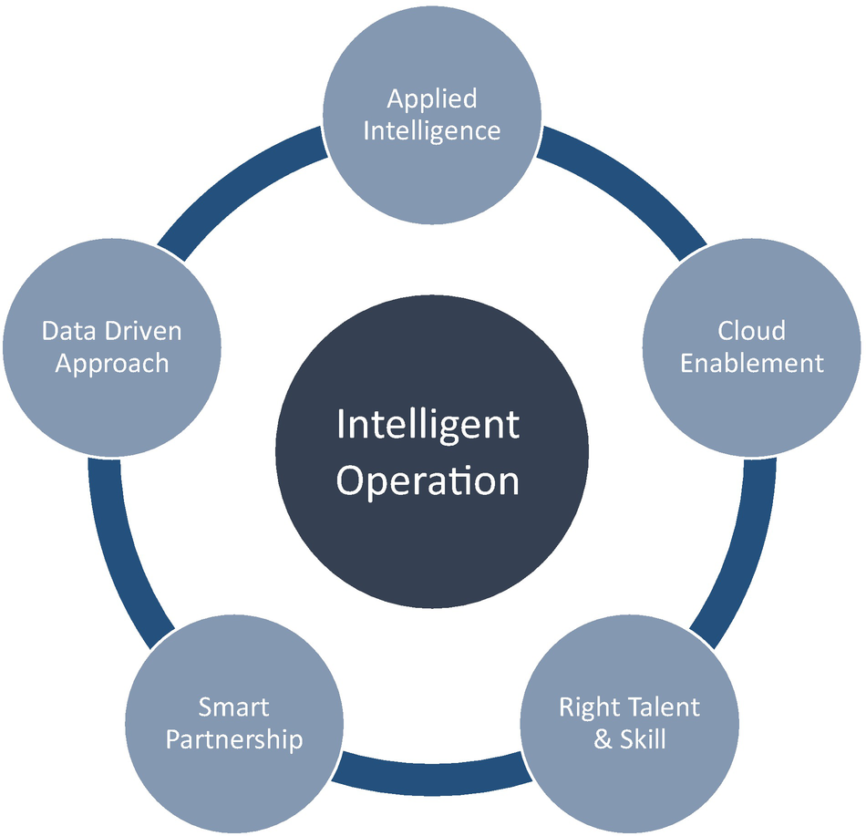

***Figure 18-1***

Intelligent operation elements

**Data-Driven Approach**

Data is at the heart of every organization today, and data is the new oil, so using data at the core of your intelligent operations is a must. According to a survey from Accenture, more than 90 percent of organizations believe that data-driven decisions will help you to generate break-through customer goals. Therefore, you must use the data effectively to achieve a sustainable competitive advantage.

To ensure you are adopting this in your core operations, you need to consider how to retrieve, store, and analyze data effectively. Data aggregation engines are either batch or streaming and can compile data from various sources to create data sets for analytics and data lakes or data meshes that offer a single source for data. This helps the operations team to get the most benefit out of data.

**Applied Intelligence**

Applied intelligence refers to four technologies that are critical to the effective use of data captured using the data-driven approach in decision-making. They are analytics, automation, streaming, and artificial intelligence. For example, AI-based natural language processing can be used to extract relevant information from unstructured data such as audio recording in self-service vehicle insurance checks.

You need the right talent to use these tools and the required right skills to understand the issues that are coming from data, and you need to determine the best way of utilizing technology to generate an output.

**Cloud Enablement**

Technologies in intelligent operations require highly talented resources to create them on your own and therefore embrace the cloud to adopt AI services that help you to create intelligent operations. The cloud services allow you to easily integrate disparate types of data from multiple sources and offer access to AI tools with analytics with the use of the right-powered machines and features. During the enablement of the cloud, you need to concentrate on modernizing legacy applications to cloud services by using a decoupling approach. Therefore, modernizing these tools should be a top priority to avoid bottlenecks hampering decision-making throughout the business.

**Right Talent and Skill**

Having the correct modern technologies is the core ingredient in the success of intelligent operations, but you may not able to implement them until you have the right skills in place. The skills needed include IT talent in the areas of artificial intelligence, cloud computing, automation, and domain. Soft skills such as dedication, culture of change, culture of innovation, and culture of agility are essential.

To meet these talent demands, you will need much more agility in human resources functions and a more flexible approach in recruitment, as well as an organization to create a path to upskill existing resources. According to World Economic Forum claims, more than half of workers will require a significant reskilling by 2022.

**Smart Partnership**

Finally, you will require a strong consortium or partner network that can extend out from the boundaries of your organization. Association with startups and academic institutions can offer a different perspective on how you make use of the data and technologies at your disposal while extending the range of expertise you can take advantage of.

In modern-day disruption, you cannot achieve anything alone. You need the right partnership. This helps you to embrace ways of working by adopting innovation and design thinking.

**AIOps**

The term AIOps was coined by Gartner in 2016. Gartner described AIOps platforms as “software systems that combine big data and AI or ML functionality to enhance and partially replace a broad range of IT operations processes and tasks, including availability and performance monitoring, event correlation, and analysis, IT service management and automation.”

To meet the ever-increasing business and technology disruptions, the IT operations team can no longer work in silos in the old traditional way by adding more people. Instead of relying on IT operations, the system needs to become intelligent, working hand in hand with IT operations staff to pinpoint service and infrastructure issues, accelerate remediation, and drive service quality.

AIOps is artificial intelligence for operations; it combines machine learning, data analytics, and many other AI technologies to automate the identification and remediation of common and recurring IT operations issues. AIOps leverages data from logs and events to monitor assets and obtain visibility into dependencies.

AIOps is about embedding advanced intelligence and automation capabilities into the core operational process. It addresses the need for operations support by combining data storage and analytics functionality to deliver relevant details. The AIOps is broad, but in operations, it focuses on diagnostic information, anomaly detection, root-cause analysis, data analysis to improve monitoring, service management, and automation. The AIOps platform enables continuous insights across IT operations.

AIOps can have a significant impact on improving key IT KPIs, including the following:

* Increasing mean time between failures (MTBF)
* Decreasing mean time detect (MTTD)
* Decreasing mean time to investigate (MTTI)
* Decreasing mean time to resolution (MTTR)
* Mean time to restore service (MTRS)
* Mean time between system incidents (MTBSI)

Figure [18-2](https://learning.oreilly.com/library/view/cloud-native-architecture/9781484272268/html/511610_1_En_18_Chapter.xhtml#Fig2) provides a failure metrics timeline across all KPIs.

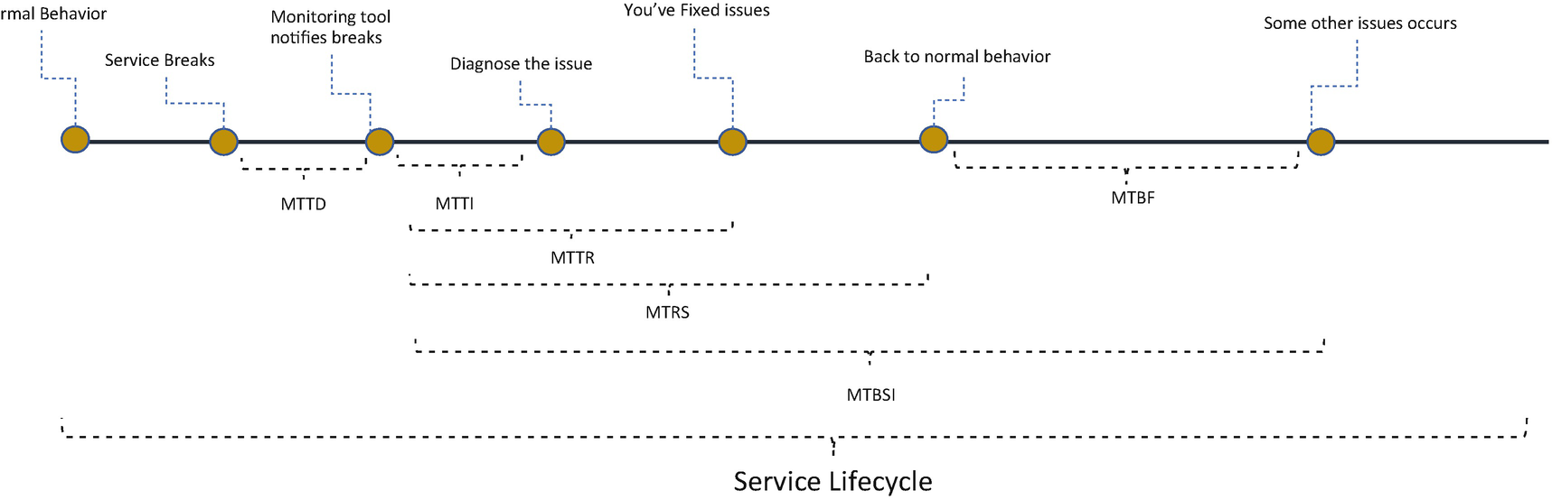

***Figure 18-2***

Failure metrics

**Central Functions**

Figure [18-3](https://learning.oreilly.com/library/view/cloud-native-architecture/9781484272268/html/511610_1_En_18_Chapter.xhtml#Fig3) shows the central function of AIOps, and these functions include the following:

* *Data gathering*: The success of AIOps depends on data collection. It gathers data from multiple sources including infrastructure, networks, applications, monitoring tools, etc. Once it collects the data, it further undergoes analytics.
* *IT assets*: It collects the inventory of IT applications and machines across organizations. It contains the metadata of IT assets and mapping of logical dependencies across services or other applications.
* *System relationship*: It establishes an event across sources to streamline what and where these events are moving. This helps to reduce human intervention.
* *Event analysis*: It processes events after establishing the relationship; it detects and predicts incidents. AIOps continually learns and relearns based on data.
* R*emediation*: It learn and improves the association between each event. Based on a prediction, it offers a recommendation, automates a response, and offers automatic self-healing.

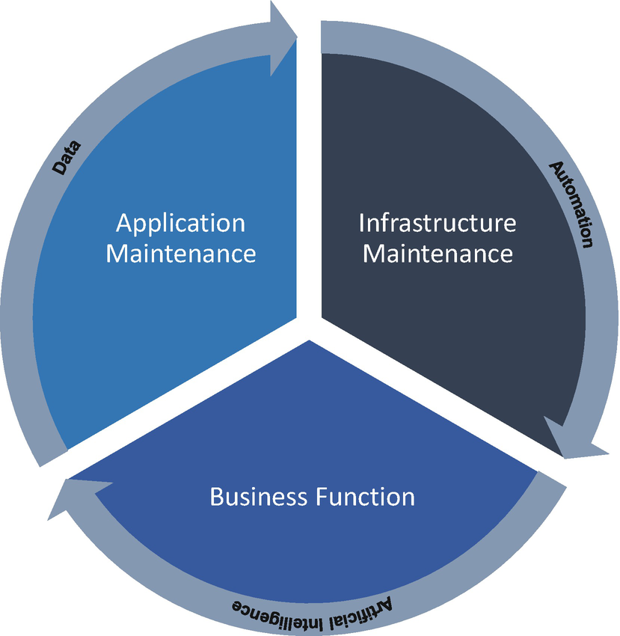

***Figure 18-3***

AIOps for modern-day systems

The following capabilities rotate across the AIOps functions.

**Artificial Intelligence**

It focuses on business priority–aligned IT automation driving efficiency, experience, predictability, and cost savings. The AIOps platform uses the following types of analytics:

* *Business disruption prediction*: This includes discovering patterns that implicitly describe correlations in historical and streamline data. These patterns are used to predict incidents with varying degrees of portability.
* *Problem and change management*: Ticket insights identify problems based on severity and criticality and identify a root-cause analysis and risk prediction.
* *Monitoring and diagnostics*: This includes integrated monitoring across applications, infrastructure and security, diagnostics, and event correlation.
* *Prediction and recommendations*: This includes AI-driven insights to monitor, provides early warnings, and remediates a delivery risk.

**Data**

Data focuses on data gathering across systems in a landscape. It gathers data from multiple sources including infrastructure, networks, applications, monitoring tools, etc. Once it collects the data, it further undergoes analytics.

You need both historical and real-time data to understand the past and predict what’s most likely to happen in the future. To achieve accuracy and a bigger picture of events, you must access a range of historical and streaming data with human-generated and machine-generated data.

For total visibility, you need to collate data in one place across all your related IT systems; this helps to define key performance indicators (KPIs).

Figure [18-4](https://learning.oreilly.com/library/view/cloud-native-architecture/9781484272268/html/511610_1_En_18_Chapter.xhtml#Fig4) shows the AIOps data architecture; it illustrates how it enables operations and automation in your enterprise landscape.

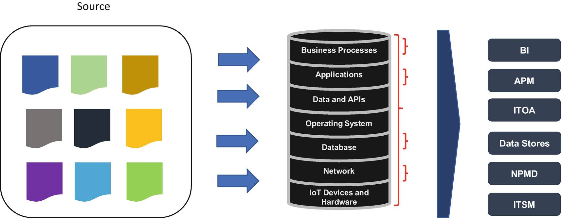

***Figure 18-4***

AIOps data process

**Automation**

Automation merges IT operation tools with the DevSecOps pipeline, as shown in Figure [18-5](https://learning.oreilly.com/library/view/cloud-native-architecture/9781484272268/html/511610_1_En_18_Chapter.xhtml#Fig5). In automation, engineers use AI to deliver services more quickly and securely. AIOps provides a significant advantage in automation by collecting and correlating data from multiple sources and increases the speed and accuracy of identifying the necessary complex relationships. An AIOps approach automates these functions across an organization’s IT operations. AIOps automation can also applies to networks, virtualization, cloud services, servers, storage, containers, and applications. Collect all logs, metrics, correlation, alerting, monitoring, and reporting.

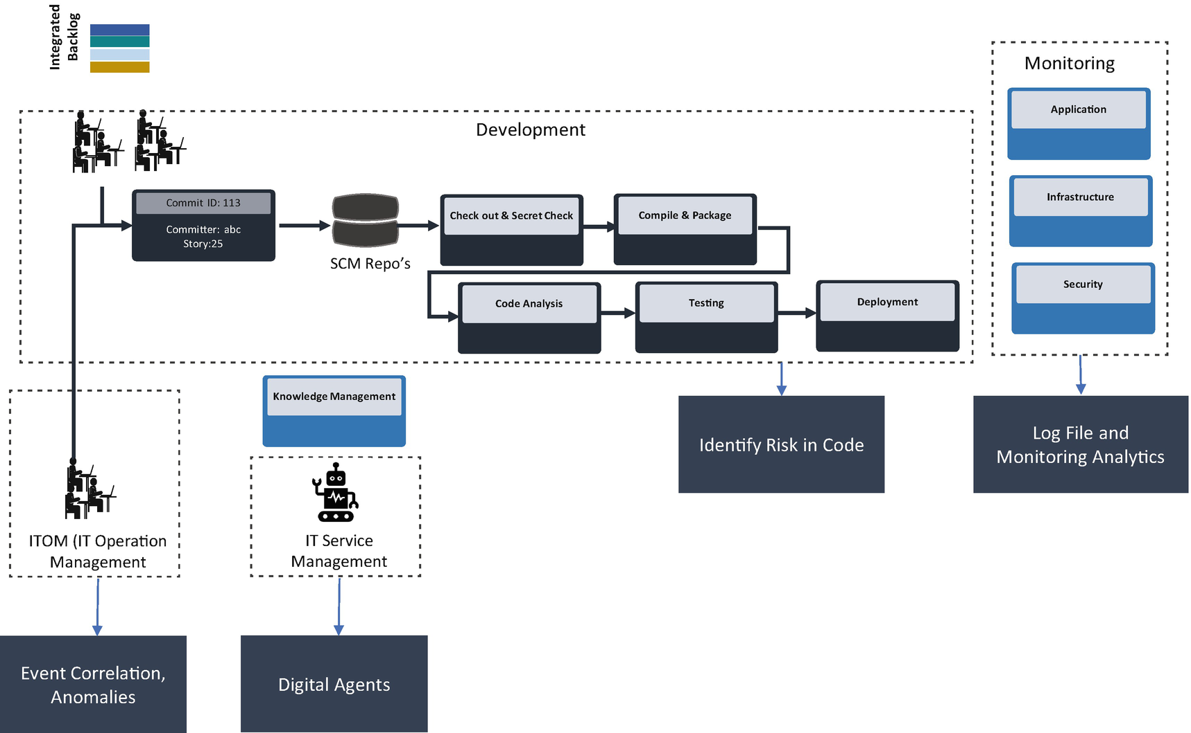

***Figure 18-5***

AIOps in lifecycle management

Increasing the use of automation, engineers are using AI to more quickly and securely deliver services that are easier to manage in the software lifecycle. Figure [18-5](https://learning.oreilly.com/library/view/cloud-native-architecture/9781484272268/html/511610_1_En_18_Chapter.xhtml#Fig5) illustrates how AIOps can be integrated with the DevOps pipeline .

* Use AIOps in development to identify the risk in code with code scanning and security scanning.
* Identify analytics with the integrated monitoring of application, infrastructure, and security.
* Identify event correlation and anomalies in ITOM.
* Digital agents like chatbots use knowledge management to provide ITSM.

**Anomaly Detection**

Anomaly detection relies on ML algorithms. A trending algorithm monitors KPIs by comparing its current behavior to its past. If the score grows anomalously large, the algorithm raises an alert. A cohesive algorithm scans a group of KPIs expected to behave similarly and raises alerts if the behavior of one or more changes. AIOps makes anomaly detection faster and more effective. Once the behavior has been identified, AIOps can monitor and detect deviations between the actual value of KPI and prediction.

**Event Correlation**

Event correlation gives you the ability to see an event storm of multiple, related warnings to identify the underlying cause of events. If any red alert or warnings occur in major systems, the traditional tools do not have features to provide insight into the problem; they just give warnings. In this case, teams try to ignore the alerts that turn out to be trivial. In AIOps, automatically group events based on similarity. This grouping reduces the burden on IT teams to search and find an item. AIOps focuses on key event groups and performs ML or rule-based actions such as closing events, consolidating duplicate events, reducing noise, etc.

**IT Service Management (ITSM)**

ITSM comprises the policies, processes, and procedures of delivering IT services. AIOps provides benefits to ITSM by letting you manage services as a group instead of one at a time. You can use these groups as a unit to define the automated response to align with your framework. For example, if one container in a pod of five containers encounters problems during the normal load period, the risk of the overall service is considered low, and then you can run automation to modify without any user-facing impact. AIOps for ITSM can help with the following:

* Manage infrastructure performance in a multicloud and hybrid cloud more consistently
* Help you to predict capacity planning
* Manage connected devices across the network in your organization

**Example Use Case of AIOps**

Here are some use cases of AIOps.

**Traditional Operations**

Figure [18-6](https://learning.oreilly.com/library/view/cloud-native-architecture/9781484272268/html/511610_1_En_18_Chapter.xhtml#Fig6) illustrates how traditional operations works.

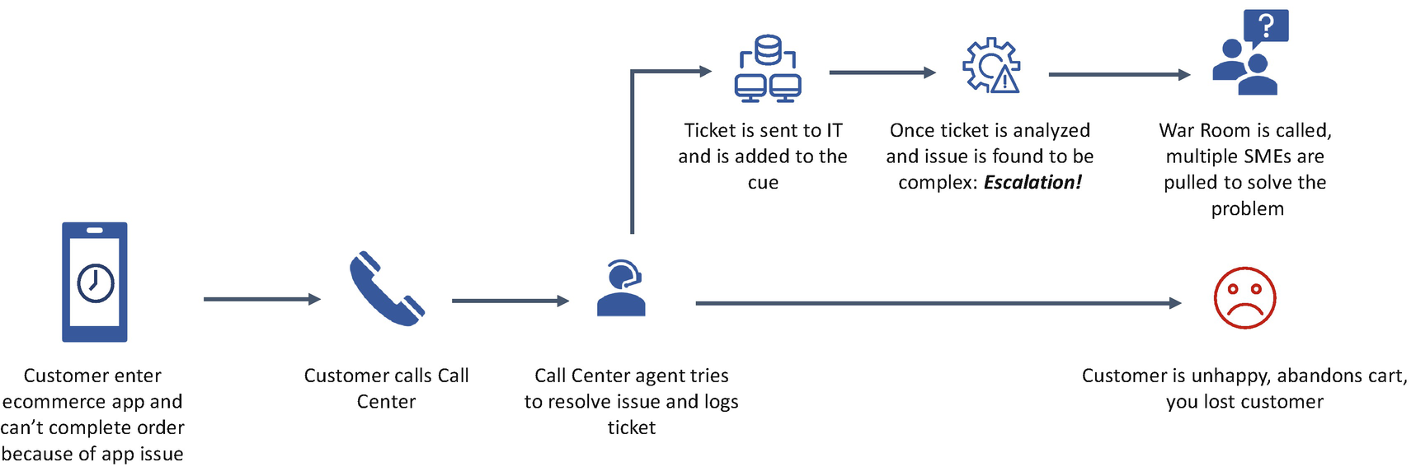

***Figure 18-6***

Traditional operations

**AIOps-Based Operation**

Figure [18-7](https://learning.oreilly.com/library/view/cloud-native-architecture/9781484272268/html/511610_1_En_18_Chapter.xhtml#Fig7) illustrates how an AIOps-enabled operation is implemented.

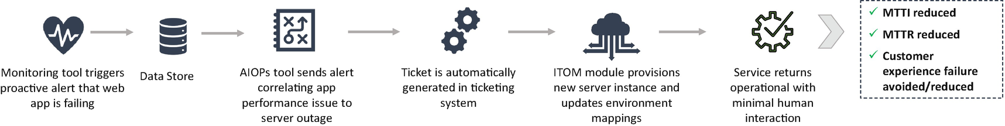

***Figure 18-7***

AIOps-enabled operation

**Capabilities of AIOps**

AIOps provide the following capabilities:

* Machine learning capabilities to help in identifying patterns in the collected data.
* A dedicated data platform for aggregating raw data and logs from various integrated monitoring tools and data sources across your enterprise landscape.
* Dashboards, analytics, and integrated consoles help IT admins and operations have clear insight of the end-to-end landscape.
* Intelligent infrastructure management to be managed with infrastructure as code and the real-time gathering of monitoring data.
* Enterprise network analytics provides a detailed view of the end-to-end network including hosts, edge, and VPC.
* ITOPs and ITSM provide IT operation and service management integration to provide intelligence in AIOps.

The following are the value levers from the previous capabilities:

* Enable value-based ROI performance tracking and decision-making.
* Accelerate IT incident identification (MTTI).
* Improve IT incident resolution time (MTTR).
* Improve management of network policies.
* Reduce the incident volume and improve resolution time.
* Improve data model accuracy and consistency.
* Reduce workforce to remediate tickets through automation.

**AIOps Transformation**

A cloud native transformation is about the evolution of technologies and the evolution of the business with new initiatives from user experience. It adds rapid growth in the volumes of data generated but poses challenges to IT operations. Similarly, the need for decision-making has increased due to the large volumes of data and analysis. These challenges make traditional IT operations obsolete and inadequate and require the correct utilization of data to extract value. As I mentioned in Capabilities of AIOps section, the IT operations team needs help to streamline predictable, remediated, and automated repetitive tasks to increase efficiency and focus on value-added activities. For this you require AIOps.

As shown in Figure [18-8](https://learning.oreilly.com/library/view/cloud-native-architecture/9781484272268/html/511610_1_En_18_Chapter.xhtml#Fig8), the AIOps journey can start in many ways, but you need a streamlined approach to transform your IT operations.

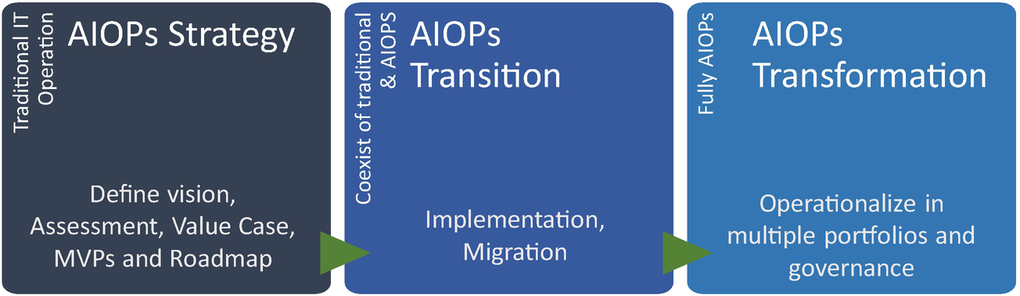

***Figure 18-8***

AIOps transformation

**AIOps Strategy**

In this phase, you required to perform the following activities:

* Assess the industry/value chain and AIOps vision
* Work with relevant stakeholders, identify and develop use cases, and select tools
* Prepare business and roadmaps
* Build a workable MVP with a clear outcome
* Establish a roadmap

**AIOps Transition**

In this phase, you required to perform the following activities:

* Conduct an assessment for existing monitoring and automation capabilities.
* Define future-state capabilities and create an AIOps architecture and migration approach.
* Conduct a platform migration.
* Train users on the new platform.
* Transition use case and value tracking to operational teams.

**AIOps Transformation**

In this phase, you are required to perform the following activities:

* Conduct an assessment of AIOps maturity and identify use cases across DevSecOps.
* Define a change journey to implement a workforce operating model and culture change.
* Establish enterprise-level integration and socialize across all the stakeholders.
* Track metrics and publish them to all stakeholders.

**Benefits of AIOps**

The main benefit of the AIOps process is that it enables IT operations to identify and resolve problems. The following are the benefits:

* *Quicker problem analysis*: AIOps can analyze the causes of issues and propose solutions more quickly compared to a manual approach.
* *False apprehensions*: AIOps reduces the fear among teams on every issue and notifies them when an action is required.
* *Predictive management*: It uses machine learning algorithms to identify problems and provide predictive reports.
* *Decision-making*: AIOps helps to make decisions by analyzing the data.

These are additional benefits:

* It brings together data sources that had previously been siloed to allow more complete analysis and insight.
* It accelerates root-cause analysis and remediation and saves time, money, and resources.
* It proactively identifies, prevents errors, and empowers IT teams to focus on higher-value analysis and optimization.

**ChatOps**

ChatOps is chat-based operation and describes a collaboration model that connects people, processes, tools, and automation seamlessly and transparently through the chat platform. It is designed to help to improve service reliability, service recovery time, and collaboration efficiency. In the ChatOps environment, the chat client serves as the primary communication channel for ongoing work. ChatOps will integrate into existing tools and processes and a collaborative communication environment to improve ticket tracking, automated incident management, and service management.

ChatOps is the streamlined use of chat applications and communication services to run development and operations functions and commands in line with human collaboration.

The following are the categories of ChatOps:

* *Notification system*: This automatically notifies if some incidents occur. Tools include PagerDuty, VictorOPs, etc.
* *Chatbots*: Conduct online chat conversation via text or voice to the customers, like Yellow Messenger, Hubot, etc.
* *Chatroom*: Chat-based tools for collaboration for effective use in automation such as Microsoft Teams, Slack, etc.

For example, during the troubleshooting of an L1 or L2 ticket, each person in our team was working in a silo and was not able to resolve the issue on time, which become an escalation to senior leadership. What was the mistake our team made? Team members should have been collaborating over a group chat, which is designed for human-to-human and human-to-machine interactions. This kind of collaboration platform maintains team communication effectively and can integrate with ITSM tools to resolve quickly.

**ChatOps Benefits**

The benefits are split into who uses ChatOps; one category of users is social and another is technical. The social users are usually nontechnical members like customers, and the technical users are engineers who will likely find greater value in the technical benefits. ChatOps is about increased sharing and collaboration across teams and customers.

The social benefits are as follows:

* Increased collaboration
* Improved customer experience
* Enhanced learning

The technical benefits are as follows:

* Increased automation
* Reduced manual intervention
* Faster response time
* Improved security and safety

**Types of ChatOps**

The concept and technology behind ChatOps have been available in the industry for quite some time. Group chats have long existed, but chatbots are quite new. With the new age of technology, there have been advancements and evolutions in the way you utilize them.

**Group Chat**

Group chat has existed for quite some time, and Internet Relay Chat (IRC) has been part of teams for many years. With the evolution of modern architecture like cloud native and AI, chat applications are evolving, and they are much more user-friendly. As shown in Figure [18-9](https://learning.oreilly.com/library/view/cloud-native-architecture/9781484272268/html/511610_1_En_18_Chapter.xhtml#Fig9), these group chat tools integrate seamlessly with additional IT operations and DevOps tools.

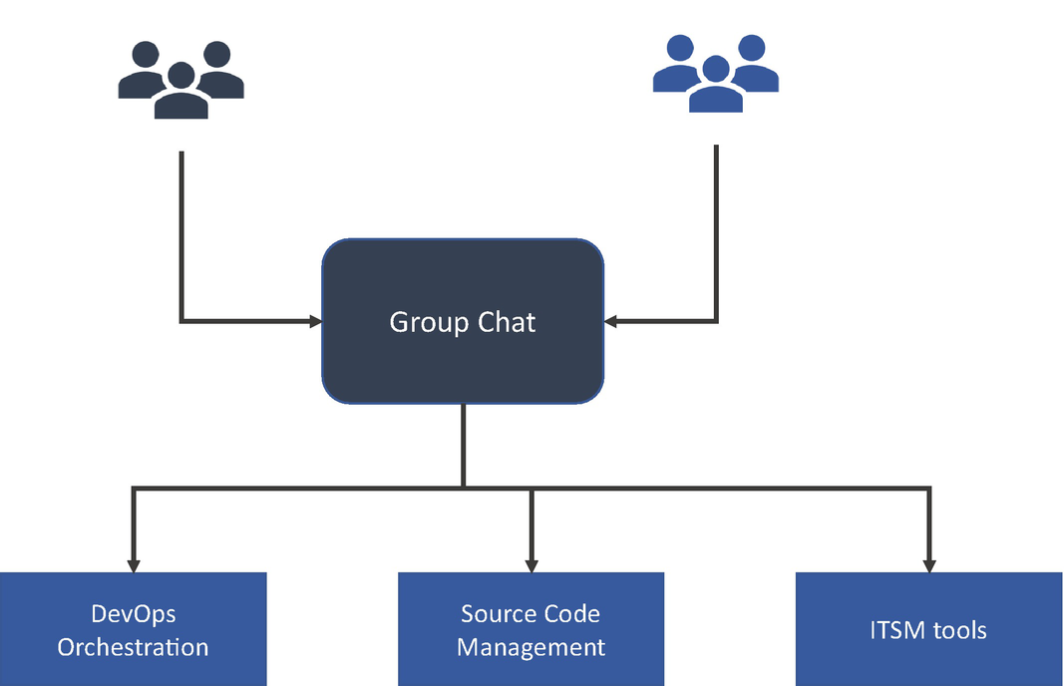

***Figure 18-9***

Group chat integration

The following are a few group chat applications:

* *Microsoft Teams*: From Microsoft, this integrates seamlessly with the other suites of Microsoft tools.
* *Slack*: From Slack Technologies, Slack has gained popularity for its user interface and user experience including SlackBot. It provides open third-party integration.
* *HipChat*: From Atlassian, this integrates seamlessly with a suite of tools such as JIRA, Confluence, etc.
* *Flow Dock*: From CA Technologies, it integrates seamlessly with a suite of tools.

There are many open source and commercial group chat tools available like Grape, Zulip, etc.

**Bots**

Recent chat bots use more sophisticated technologies and do not require hosting, configuration, or support in your organization. Currently, there are several well-known chatbots available, and they are more focused on a business-to-customer (B2C) style. As shown in Figure [18-10](https://learning.oreilly.com/library/view/cloud-native-architecture/9781484272268/html/511610_1_En_18_Chapter.xhtml#Fig10), the chatbots integrate with various capabilities like DevOps, SCM, authentication, operation tools, and also the cloud.

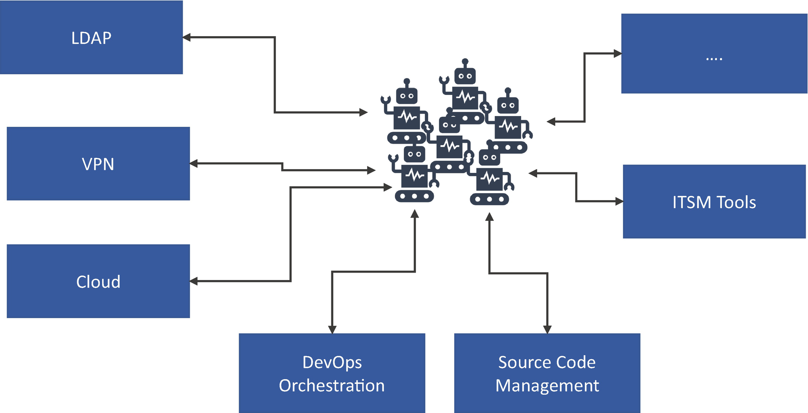

***Figure 18-10***

Chat bot integration

* *Yellow Messenger*: This is the most used bot today and supports B2C and IT operations.
* *Hubot*: From GitHub, this is a well-known chatbot that supports B2C and IT operations.
* *Lita*: This supports B2C and IT operations and is easy to implement.

There are many chatbots available that support the same features as the ones listed.

**ChatOps in Service Support**

Generally, a chatbot offers the following services:

* *Customer support service*: In customer service, a chatbot can help you with the onboarding process, resolving issues on the first customer contact, predicting their needs, and keeping the customer engaged.
* *Sales service*: In this service, the chatbot helps you to identify customer inhibitions and remind users about products and payments.
* *Marketing services*: In this service, the chatbot helps you better segment customers, offer personalized ads with AI conversations, etc.
* *ITSM services*: In this service, a chatbot helps with intelligent operations such as incident management, access request, monitoring and alerting, and FAQs.
* *Operation services*: In this service, the chatbot provides automatic trigger workflows, processes with unstructured data, auto-escalation, etc.
* *Automation services*: In this service, the chatbot helps you automate the contact center, conversational IVR automation, voice authentication, and automation.
* *HR services*: In this service, the chatbot can help with employee productivity and satisfaction, omnichannel, and ticket management.

**ChatOps (Bot) Architecture**

Chatbots are used in various services including an omnichannel conversational enablement platform for enterprises that allows you to create chatbots on various channels like web, mobile, telephone, Google Assistant, and other group chat tools like Teams, Slack, etc.

The architecture diagram in Figure [18-11](https://learning.oreilly.com/library/view/cloud-native-architecture/9781484272268/html/511610_1_En_18_Chapter.xhtml#Fig11) illustrates how the chatbots operate to support your enterprises. This architecture may not be standard across all chatbots; the source and how you analyze the data differs.

In ChatOps, the user interacts with the chatbot through a chat client, making it possible for all team members to maintain awareness, even through mobile devices. The remediation steps are preserved in the chat record, which assists with onboarding and fine-tuning best practices. These best practices can then be incorporated into orchestration scripts for the chatbot. Figure [18-11](https://learning.oreilly.com/library/view/cloud-native-architecture/9781484272268/html/511610_1_En_18_Chapter.xhtml#Fig11) illustrates further.

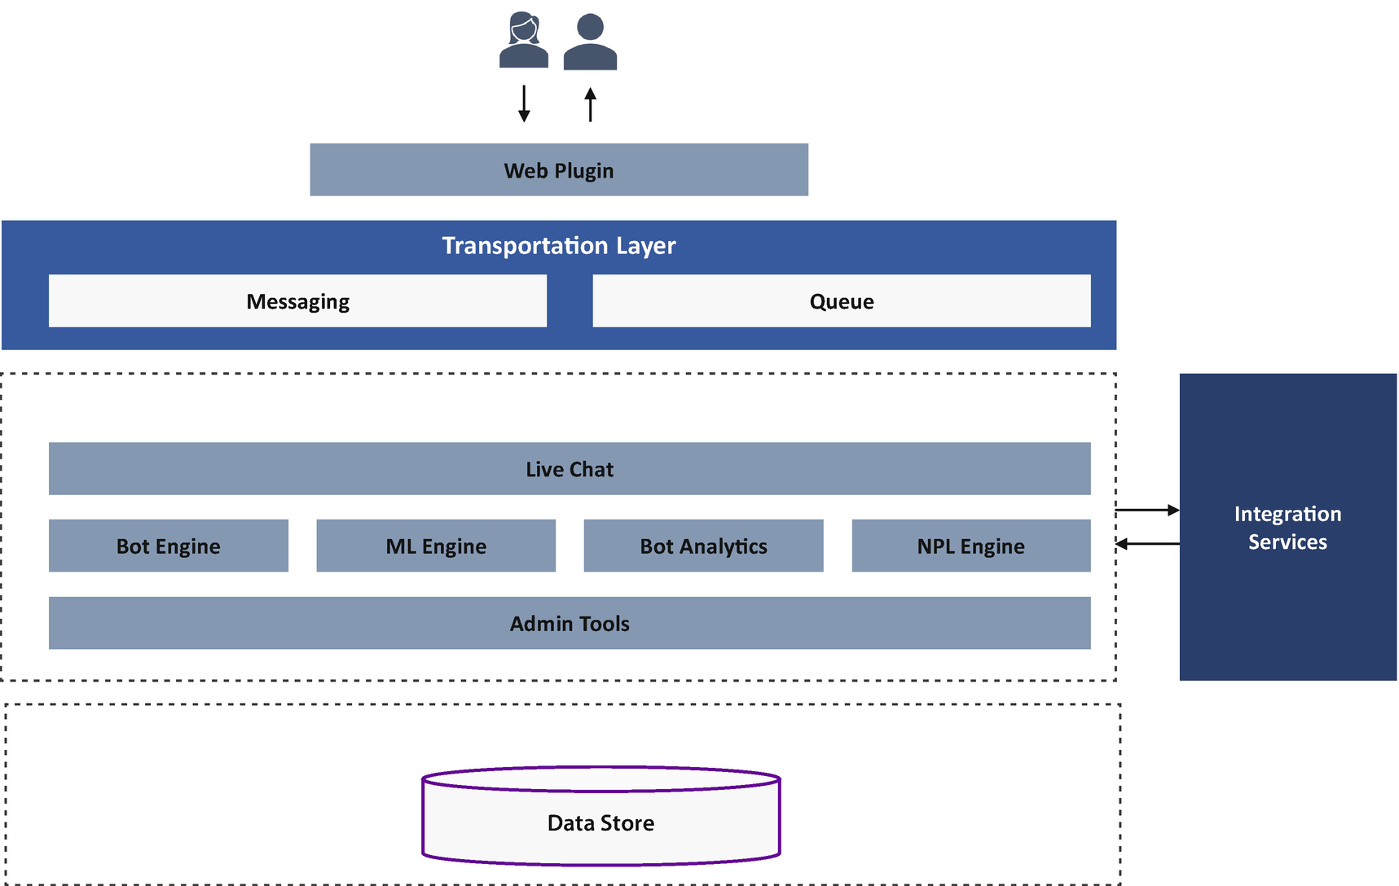

***Figure 18-11***

Chatbot architecture

The architecture uses plugins that integrate with your web applications and messaging layer to connect users with a chatbot engine and establishes a queue to track all the requests and avoid losing any packets or requests.

The chatbot engine contains database storage for search, analytics database, and a persistent database to store details. The process engine consists of an ML engine, NLP engine, and analytics engine to process the chats. The integration services integrate various services in an enterprise.

The chatbot integrates with knowledge management to process all such conversations, context, and commands.

The chatbots also integrate with voice integration and language models for various language conversions.

**Industry Example Use Cases**

Here are some use cases:

**Group Chat Use Case: Microsoft Teams–Based Chatbot with AI Is Integrated with ServiceNow**

Microsoft Teams–based chatbot solution helps the client to serve its ServiceNow users with the following assistance:

* Required to know the status of the ticket
* Resetting customer credentials
* Generic order management

The chatbot solution benefits the client as follows:

* Reducing service desk tickets
* Resolving ticket faster
* Offering enhanced customer experience

**Chatbot Use Case: Payment Industry to Resolve Billing Queries and Create Case Management Requests**

One company used Yellow Messenger and an integrated solution to the web application and helped the client with the following assistance:

* Required to know the invoice
* Required to get itemized billing
* Create an incident on case management
* Payment instruction issues
* FAQ

We integrated Yellow Messenger into a web application with text and voice-based search and helped the client to create an incident, provide status, check billing details, etc.

**Summary**

IT leverages application monitoring tools to maintain operational efficiency; however, each tool collects a lot of data that needs to be maintained. When a team fails to detect vulnerabilities and issues in your cloud native services, it leads to security threats. By using AIOps, IT teams can automate and improve monitoring and remediation.

An organization that adopts AIOps can see the benefits by addressing operational issues and analyzing issues quicker and faster.